Janine Maere, MD 209 S. Prospect Dr.
309-336-0190 Office Suite 1
Bloomington, IL
61704

ACUPUNCTURE CONSULTATION
1. Please complete the enclosed medical history forms, and bring them with you to your first appointment.
2. We require a minimum 24 hour notice of cancellation if you are unable to keep your appointment.
IMPORTANT: Please complete this document as thoroughly as possible. All information is strictly confidential.
Date: ___________________
Name (last, first, MI):__________________________________________________________________
Address: ____________________________________________________________________________
City: _________________ State:_______ Zip Code:_________________
Phone Number:_________________________
Email:_______________________________________________________________
Age: ______ Date of Birth (MM/DD/YY): _____________________ Sex: Female/ Male
Marital Status (circle one): Married/ Single/ Divorced/ Widowed
Occupation: _________________________________________________________________________
Primary Health Care Physician/MD: _____________________________________________________
Emergency Contact #1: ____________________________ Contact Number:__________________
Emergency Contact #2: ____________________________ Contact Number: ________________
How did you hear about our office: _________________________________________________________________________________ If referred, please give the name of who referred you: __________________________________________________________________________________
Have you ever had acupuncture before: Y/N
If yes, from whom:____________________________________________________________________
For what:____________________________________________________________________________
Have you been treated by a Homeopath before? Y/N
If yes, from whom:____________________________________________________________________
For what:____________________________________________________________________________
Do you have a pacemaker or other implantable device: Yes No
MAJOR COMPLAINTS, IN ORDER OF IMPORTANCE
1. __________________________________________ 2. ______________________________________ 3. __________________________________________ 4. ______________________________________ 5. __________________________________________ 6. ______________________________________
How do these conditions impair your daily activities? _________________________________________
_____________________________________________________________________________________
_____________________________________________________________________________________
PAST MEDICAL HISTORY
Check any that you have had in the past:
❏ Diabetes ❏ Heart Disease ❏ Asthma ❏ Jaundice ❏ Syphilis
❏ Meningitis ❏ Epilepsy ❏ Paralysis ❏ Other Lung Illness
❏ Allergies ❏ CVA (stroke) ❏ Pneumonia ❏ Gonorrhea ❏ Measles
❏ HIV ❏ High Fever ❏ Cancer ❏ Other Liver Illness
❏ Glaucoma ❏ Vein Condition ❏ Tuberculosis ❏ Mumps ❏ Chicken Pox
❏ Polio ❏ Hepatitis ❏ Migraines ❏ Other Heart Illness
❏ Rheumatic Fever ❏ Thyroid Disorder ❏ Emphysema
❏ Bleeding Tendency ❏ Nervous Disorder ❏ Mononucleosis
❏ Multiple Sclerosis ❏ High Blood Pressure ❏ Other Kidney Illness
❏ Other ________________________________________________________________________

Please list any major injuries you may have had in the past: _______________________________
________________________________________________________________________________

What vaccinations have you had: _____ Tetanus- Date:___________
_____Shingles- Date:___________ _____Pneumonia- Date:__________
_____Meningitis- Date:__________ _____Gardisil- Dates:___________
_____Chicken Pox -Date:__________ _____Hepatitis B- Dates:____________
_____Hepatitis A- Dates:___________ _____MMR- Dates:_____________
_____Influenza – Date:____________

Did you have any adverse reactions to them? Please list information below:
_____________________________________________________________________________________

Past Surgical History
Please list any major surgeries you may have had in the past: ______________________________
________________________________________________________________________________
If you are over 50, have you had a colonoscopy? Y / N If so, when:____________________________

Medications and Supplements
Please list all prescribed and over the counter medications, supplements, and vitamins you are currently taking routinely. Indicate the dosage and reason for taking, as well. Write on the back of the sheets if needed.
Name _______________________________ dosage __________ purpose ________________
Name _______________________________ dosage __________ purpose ________________
Name _______________________________ dosage __________ purpose ________________
Name _______________________________ dosage __________ purpose ________________
Name _______________________________ dosage __________ purpose ________________
If additional medications, please list on the back of this form.

Allergies
Are you allergic to any medications : Y / N
Are you allergic to any supplements/herbs: Y / N
Are you allergic to any food: Y / N
Are you allergic anything in the environment: Y / N
Are you allergic to anything else: Y / N
If so, please list:________________________________________________________________________

Family History
Relative Alive Health Conditions/Cause of Death_______________________________
Mother Y / N
Father Y / N
MGF Y / N
MGM Y / N
PGF Y / N
PGM Y / N
Sister Y / N
Brother Y / N
Other Y / N

Diet & Lifestyle
Do you drink caffeine: Y / N how much: _________ coffee / tea / soda/ energy drinks
Do you drink alcohol: Y / N how much: _________
Do you smoke: Y / N how much: _________
Do you chew tobacco: Y / N how much: __________
Do you do recreational drugs: Y / N which ones: _______________________________________

Patient Profile Please clearly mark any areas of pain and any scars (please indicate which of the areas are scars)
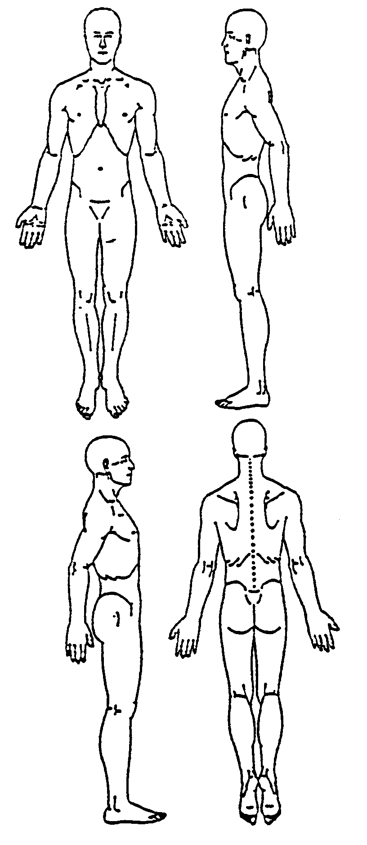

Is the pain:
❏ Sharp ❏ Cramping ❏ Fixed ❏ Burning ❏ Dull
❏ Aching ❏ Moving ❏ Other:

Do the following improve the pain?
❏ Pressure ❏ Exercise ❏ Cold ❏ Heat ❏ Other:
Do the following worsen the pain?
❏ Pressure ❏ Cold ❏ Heat ❏ Other:

Please check the following that currently pertain to you (if you have symptoms in the following categories, it indicates that you have a problem with that organ’s function):
OVERALL TEMPERATURE (Kidney Function)
❏ Sweaty feet ❏ Hot body temperature (sensation) ❏ Cold body temperature (sensation)
❏ Afternoon flushes ❏ Hot flashes any time of the day ❏ Heat in the hands, feet, and chest
❏ Night sweats ❏ Thirsty ❏ Perspire easily ❏ Lack of perspiration
❏ Take water to bed

OVERALL ENERGY (Lung, Kidney function)
❏ Shortness of breath ❏ Low energy ❏ Difficulty keeping eyes open in the daytime
❏ Feel worse after exercise ❏ General weakness ❏ Easily catch colds

OVERALL BLOOD (Liver, Spleen, Heart function)
❏ Dizziness ❏ See floating black spots

HEART FUNCTION
❏ Palpitations ❏ Anxiety ❏ Drink coffee (# of cups per week:_______)
❏ Sores on the tip of the tongue ❏ Restlessness ❏ Mental confusion
❏ Chest pain traveling to shoulder ❏ Frequent dreams ❏ Wake unrefreshed

LUNG FUNCTION
❏ Nasal Discharge (Color: _______________) ❏ Allergies (To what?____________________)
❏ Headache (Location: __________________) ❏ Smoke cigarettes (# of cigarettes a day: ___)
❏ Cough ❏ Nose Bleeds ❏ Sinus Congestion ❏ Alternating fever and chills
❏ Dry Mouth ❏ Stiff neck ❏ Stiff shoulders ❏ Melancholy
❏ Sadness ❏ Dry throat ❏ Dry nose ❏ Dry skin
❏ Sore throat ❏ Difficulty breathing ❏ Sneezing ❏ Achy feeling

SPLEEN FUNCTION
❏ Low appetite ❏ Abrupt weight gain ❏ Abrupt weight loss ❏ Abdominal bloating
❏ Prolapsed organs (previously diagnosed, which organ? ____________)
❏ Abdominal gas ❏ Gurgling noise in the stomach ❏ Fatigue after eating
❏ Easily bruised ❏ Hemorrhoids ❏ Pensive ❏ Worry
❏ Over-thinking

SPLEEN, STOMACH, LARGE INTESTINE, SMALL INTESTINE FUNCTION
❏ Loose ❏ Constipated ❏ Incomplete ❏ Diarrhea
❏ Blood in stools ❏ Mucous in stools ❏ Undigested food in stools

DAMPNESS TRAPPED IN THE BODY
❏ Mental heaviness ❏ Mental sluggishness ❏ Mental fogginess ❏ Snoring
❏ General sensation of heaviness in the body ❏ Swollen hands ❏ Swollen feet
❏ Swollen joints ❏ Chest congestion ❏ Nausea

STOMACH FUNCTION
❏ Large appetite ❏ Bad breath ❏ Mouth (canker) sores
❏ Heartburn ❏ Acid regurgitation ❏ Burning sensation after eating
❏ Ulcer (diagnosed) ❏ Belching ❏ Bleeding, swollen or painful gums
❏ Hiccups ❏ Stomach pain ❏ Vomiting

LIVER, GALLBLADDER FUNCTION
❏ Alternating diarrhea and constipation ❏ Headache at the top of the head
❏ Tight sensation in the chest ❏ Bitter taste in the mouth
❏ High-pitched ringing in the ears ❏ Gall stones (history or current)
❏ Frustration ❏ Depression ❏ Irritability ❏ Skin rashes
❏ Chest pain ❏ Anger easily ❏ Tingling sensation ❏ Numbness
❏ Muscle spasms ❏ Muscle twitching ❏ Muscle cramping ❏ Seizures
❏ Convulsions ❏ Lump in the throat ❏ Neck tension ❏ Drink alcohol
❏ Shoulder tension ❏ Limited Range-of-Motion, neck
❏ Limited Range-of-Motion, shoulder
❏ Sexually transmitted disease (Which? ______________________________________ )
❏ Recreational drugs (Which? _________________ , How much per week? ________ )
❏ Frequently unable to adapt to stress (What causes the stress? __________________ )

EYES (Liver function)
❏ Itchy ❏ Bloodshot ❏ Hot ❏ Dry
❏ Watery ❏ Gritty ❏ Blurry vision ❏ Decreased night vision
❏ Near-sighted ❏ Far-sighted

KIDNEY, URINARY BLADDER FUNCTION
❏ Frequent cavities ❏ Sore knees ❏ Weak knees
❏ Cold sensation in the knees ❏ Low back pain ❏ Memory problems
❏ Excessive hair loss ❏ Kidney stones ❏ Low-pitched ringing the ears
❏ Bladder infections ❏ Easily broken bones ❏ Lack of bladder control
❏ Fear ❏ Easily startled ❏ Wake during the night twice to urinate

URINATION
❏ Normal color ❏ Dark yellow ❏ Clear ❏ Reddish
❏ Cloudy ❏ Scanty ❏ Profuse ❏ Strong color
❏ Burning ❏ Urgent ❏ Frequent ❏ Painful
❏ Discharge ❏ Difficult

LIBIDO
❏ Normal ❏ High ❏ Low

WOMEN ONLY
Regular menstrual cycle? ❏ Y ❏ N Number of children: _______ Age of first menstruation: ________ Average number of days of flow: ___________ Vaginal discharge? ❏ Y ❏ N Pregnant? ❏ Y ❏ N Number of pregnancies: __________________ Age of menopause (if applicable): ___________________ Average number of days of entire cycle: ______________________ Bleeding between periods? ❏ Y ❏ N
Do you experience any of the following pre-menstrual syndromes?
❏ Nausea ❏ Food cravings ❏ Depression ❏ Vomiting
❏ Headaches ❏ Irritability ❏ Water retention ❏ Migraines
❏ Anxiety ❏ Breast swelling ❏ Breast tenderness
❏ Sharp pain, Where? _________________
❏ Dull pain, Where? ________________
Please fill out the following menstrual chart: | Day 1 | Day 2 | Day 3 | Day 4 | Day 5 | Day 6 | Day 7
Color (normal, bright red, pale, rust, brown,
dark, purple, other)
Amount of Flow (normal, heavy, light)
Pain/Cramps (location, dull, sharp, other)
Clots (large, small, black, red, purple, other)
Vomiting (check if yes)
Nausea (check if yes)
Other

MEN ONLY
❏ Swollen testes ❏ Testicular pain ❏ Impotence
❏ Feeling of coldness or numbness in external genitalia
❏ Other ____________________________

